**NODE-RED JASON FILE**

* **To get to the built-in test tool, click on the Test tab. Click on the Provide input data as JSON icon and paste the following data under Body:**

**npm install node-red-contrib-watson-machine-learning**

"input_data":[

{

"fields":[

"gender",

"SeniorCitizen",

"Partner",

"Dependents",

"tenure",

"PhoneService",

"MultipleLines",

"InternetService",

"OnlineSecurity",

"OnlineBackup",

"DeviceProtection",

"TechSupport",

"StreamingTV",

"StreamingMovies",

"Contract",

"PaperlessBilling",

"PaymentMethod",

"MonthlyCharges",

"TotalCharges"

],

"values":[

[

"Female",

0,

"No",

"No",

1,

"No",

"No phone service",

"DSL",

"No",

"No",

"No",

"No",

"No",

"No",

"Month-to-month",

"No",

"Bank transfer (automatic)",

25.25,

25.25

]

]

}

]

}

* Click the Predict button and the model will be called with the input data. The results will display in the *Result* window. Scroll down to the bottom to see either a "Yes" or a "No" for Churn:

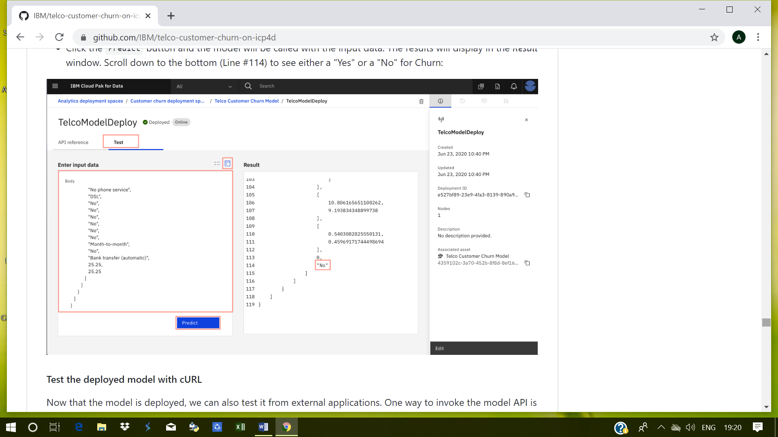

**Test the deployed model with cURL**